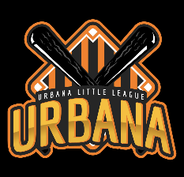
Zero Tolerance Policy
Our baseball program is committed to providing a positive and inclusive experience for all participants. We have a zero-tolerance policy for any form of verbal or physical abuse, harassment, bullying, discrimination, or unsportsmanlike conduct. This policy applies to players, coaches, parents and spectators. Any concerns should be shared with the ULL Board of Directors. (urbanalittleleague@gmail.com)

Any individual forum in violation of this policy will face immediate consequences, which may include but are not limited to warnings, suspension from games, expulsion from the program, and reporting to the appropriate authorities.

We expect all participants and stakeholders to demonstrate respect for each other, the officials, and the spirit of the game. Let’s work together to create a safe and enjoyable environment for our young athletes to learn, grow, and have fun.

Urbana Little League

